IST 718 Final Group Project Statement

### Team Member

Daniel Pearl

Emilio Ramos Monzalvo

Mahsa Saadati

Stephen Bookstaber

Shan Jiang

### Project Summary

This project is focusing on using different algorithms to train, build, and compare models that can best perform the task of image recognition for flower classification.

### Dataset

The data set used for this project is from Kaggle (<https://www.kaggle.com/aymenktari/flowerrecognition>). The dataset contains over 24000 images of flowers in 59 different species. There are somewhere between ~300 to ~500 images in each class. The size of the dataset is over 15GB.

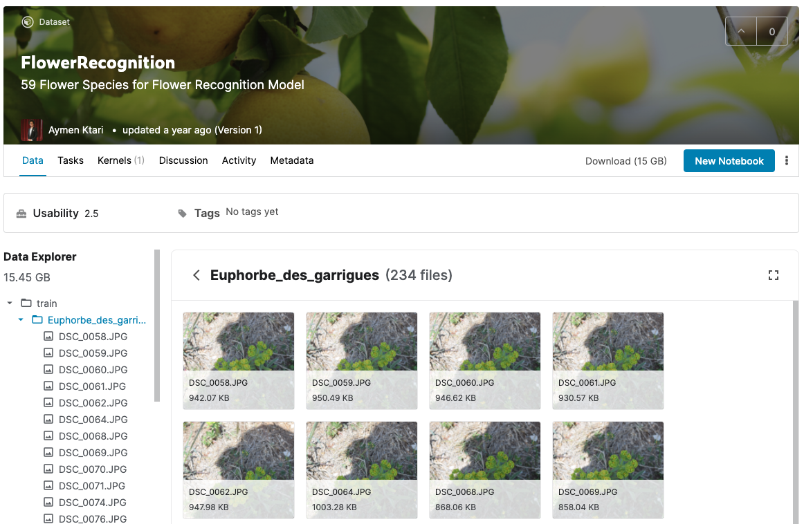

### Applications

The algorithm can be built into a mobile UI where users can snap a picture of a flower and upload the image for image processing and recognition and return the species classification to the end user.

The model can be adaptive and as we feed in more images that are labeled, we can expand its capabilities to recognize species beyond the preloaded dataset.

### Challenges

The size of the dataset is quite large. We are likely to sample a subset of the species and/or images of each species for our model building since we have limited resources.